Selection: 1

| Please choose a lesson, or type 0 to return to course menu.

1: Introduction 2: Probability1 3: Probability2

4: ConditionalProbability 5: Expectations 6: Variance

7: CommonDistros 8: Asymptotics 9: T Confidence Intervals

10: Hypothesis Testing 11: P Values 12: Power

13: Multiple Testing 14: Resampling

Selection: 5

| Attempting to load lesson dependencies...

| Package ‘ggplot2’ loaded correctly!

| | | 0%

| Expectations. (Slides for this and other Data Science courses may be found at github

| https://github.com/DataScienceSpecialization/courses/. If you care to use them, they

| must be downloaded as a zip file and viewed locally. This lesson corresponds to

| 06_Statistical_Inference/04_Expectations.)

...

| |== | 2%

| In this lesson, as you might expect, we'll discuss expected values. Expected values

| of what, exactly?

...

| |==== | 5%

| The expected value of a random variable X, E(X), is a measure of its central

| tendency. For a discrete random variable X with PMF p(x), E(X) is defined as a sum,

| over all possible values x, of the quantity x*p(x). E(X) represents the center of

| mass of a collection of locations and weights, {x, p(x)}.

...

| |===== | 7%

| Another term for expected value is mean. Recall your high school definition of

| arithmetic mean (or average) as the sum of a bunch of numbers divided by the number

| of numbers you added together. This is consistent with the formal definition of E(X)

| if all the numbers are equally weighted.

...

| |======= | 9%

| Consider the random variable X representing a roll of a fair dice. By 'fair' we mean

| all the sides are equally likely to appear. What is the expected value of X?

> 6

[1] 6

| Not quite, but you're learning! Try again. Or, type info() for more options.

| Add the numbers from 1 to 6 and divide by 6.

> (1+2+3+4+5+6)/6

[1] 3.5

| Keep up the great work!

| |========= | 12%

| We've defined a function for you, expect_dice, which takes a PMF as an input. For our

| purposes, the PMF is a 6-long array of fractions. The i-th entry in the array

| represents the probability of i being the outcome of a dice roll. Look at the

| function expect_dice now.

> expect_dice

function(pmf){ mu <- 0; for (i in 1:6) mu <- mu + i*pmf[i]; mu}

<environment: 0x0000000005f6aac0>

| That's the answer I was looking for.

| |=========== | 14%

| We've also defined PMFs for three dice, dice_fair, dice_high and dice_low. The last

| two are loaded, that is, not fair. Look at dice_high now.

> dice_high

[1] 0.04761905 0.09523810 0.14285714 0.19047619 0.23809524 0.28571429

| Keep working like that and you'll get there!

| |============= | 16%

| Using the function expect_dice with dice_high as its argument, calculate the expected

| value of a roll of dice_high.

> expect_dice(dice_high)

[1] 4.333333

| You are doing so well!

| |=============== | 19%

| See how the expected value of dice_high is higher than that of the fair dice. Now

| calculate the expected value of a roll of dice_low.

> expect_dice(dice_low)

[1] 2.666667

| You are quite good my friend!

| |================ | 21%

| You can see the effect of loading the dice on the expectations of the rolls. For

| high-loaded dice the expected value of a roll (on average) is 4.33 and for low-loaded

| dice 2.67. We've stored these off for you in two variables, edh and edl. We'll need

| them later.

...

| |================== | 23%

| One of the nice properties of the expected value operation is that it's linear. This

| means that, if c is a constant, then E(cX) = c*E(X). Also, if X and Y are two random

| variables then E(X+Y)=E(X)+E(Y). It follows that E(aX+bY)=aE(X)+bE(Y).

...

| |==================== | 26%

| Suppose you were rolling our two loaded dice, dice_high and dice_low. You can use

| this linearity property of expectation to compute the expected value of their

| average. Let X_hi and X_lo represent the respective outcomes of the dice roll. The

| expected value of the average is E((X_hi + X_lo)/2) or .5 *( E(X_hi)+E(X_lo) ).

| Compute this now. Remember we stored the expected values in edh and edl.

> 0.5*(4.333333 + 2.666667)

[1] 3.5

| All that hard work is paying off!

| |====================== | 28%

| Did you expect that?

1: Yes

2: No

Selection: 1

| You nailed it! Good job!

| |======================== | 30%

| For a continuous random variable X, the expected value is defined analogously as it

| was for the discrete case. Instead of summing over discrete values, however, the

| expectation integrates over a continuous function.

...

| |========================= | 33%

| It follows that for continuous random variables, E(X) is the area under the function

| t*f(t), where f(t) is the PDF (probability density function) of X. This definition

| borrows from the definition of center of mass of a continuous body.

...

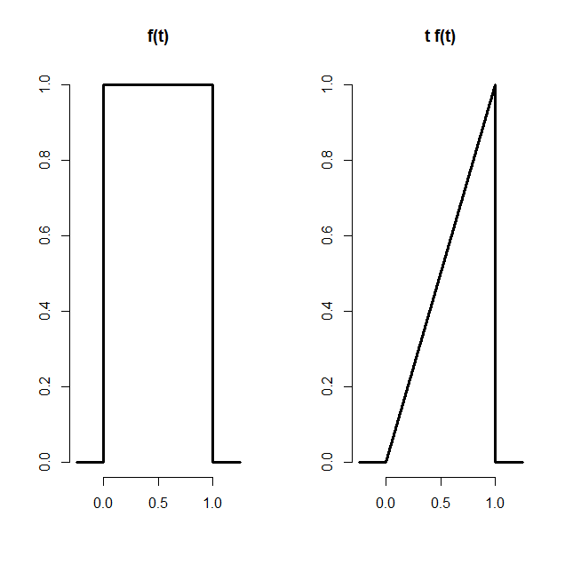

| |=========================== | 35%

| Here's a figure from the slides. It shows the constant (1) PDF on the left and the

| graph of t*f(t) on the right.

...

| |============================= | 37%

| Knowing that the expected value is the area under the triangle, t*f(t), what is the

| expected value of the random variable with this PDF?

1: .25

2: .5

3: 1.0

4: 2.0

Selection: 2

| That's a job well done!

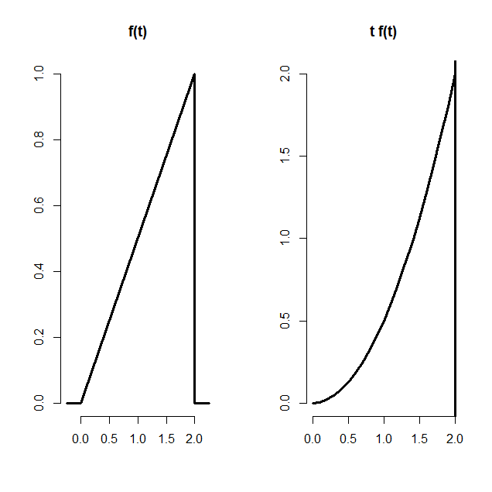

| |=============================== | 40%

| For the purposes of illustration, here's another figure using a PDF from our previous

| probability lesson. It shows the triangular PDF f(t) on the left and the parabolic

| t*f(t) on the right. The area under the parabola between 0 and 2 represents the

| expected value of the random variable with this PDF.

...

| |================================= | 42%

| To find the expected value of this random variable you need to integrate the function

| t*f(t). Here f(t)=t/2, the diagonal line. (You might recall this from the last

| probability lesson.) The function you're integrating over is therefore t^2/2. We've

| defined a function myfunc for you representing this. You can use the R function

| 'integrate' with parameters myfunc, 0 (the lower bound), and 2 (the upper bound) to

| find the expected value. Do this now.

> integrate(myfunc, 0, 2)

1.333333 with absolute error < 1.5e-14

| You nailed it! Good job!

| |================================== | 44%

| As all the examples have shown, expected values of distributions are useful in

| characterizing them. The mean characterizes the central tendency of the distribution.

| However, often populations are too big to measure, so we have to sample them and then

| we have to use sample means. That's okay because sample expected values estimate the

| population versions. We'll show this first with a very simple toy and then with some

| simple equations.

...

| |==================================== | 47%

| We've defined a small population of 5 numbers for you, spop. Look at it now.

> spop

[1] 1 4 7 10 13

| Nice work!

| |====================================== | 49%

| The R function mean will give us the mean of spop. Do this now.

> mean(spop)

[1] 7

| You are amazing!

| |======================================== | 51%

| Suppose spop were much bigger and we couldn't measure its mean directly and instead

| had to sample it with samples of size 2. There are 10 such samples, right? We've

| stored this for you in a 10 x 2 matrix, allsam. Look at it now.

> allsam

[,1] [,2]

[1,] 1 4

[2,] 1 7

[3,] 1 10

[4,] 1 13

[5,] 4 7

[6,] 4 10

[7,] 4 13

[8,] 7 10

[9,] 7 13

[10,] 10 13

| Your dedication is inspiring!

| |========================================== | 53%

| Each of these 10 samples will have a mean, right? We can use the R function apply to

| calculate the mean of each row of the matrix allsam. We simply call apply with the

| arguments allsam, 1, and mean. The second argument, 1, tells 'apply' to apply the

| third argument 'mean' to the rows of the matrix. Try this now.

> apply(allsam, 1, mean)

[1] 2.5 4.0 5.5 7.0 5.5 7.0 8.5 8.5 10.0 11.5

| You're the best!

| |============================================ | 56%

| You can see from the resulting vector that the sample means vary a lot, from 2.5 to

| 11.5, right? Not unexpectedly, the sample mean depends on the sample. However...

...

| |============================================= | 58%

| ... if we take the expected value of these sample means we'll see something amazing.

| We've stored the sample means in the array smeans for you. Use the R function mean on

| the array smeans now.

> mean(smeans)

[1] 7

| That's the answer I was looking for.

| |=============================================== | 60%

| Look familiar? The result is the same as the mean of the original population spop.

| This is not because the example was specially cooked. It would work on any

| population. The expected value or mean of the sample mean is the population mean.

| What this means is that the sample mean is an unbiased estimator of the population

| mean.

...

| |================================================= | 63%

| Formally, an estimator e of some parameter v is unbiased if its expected value equals

| v, i.e., E(e)=v. We can show that the expected value of a sample mean equals the

| population mean with some simple algebra.

...

| |=================================================== | 65%

| Let X_1, X_2, ... X_n be a collection of n samples from a population with mean mu.

| The mean of these is (X_1 + X_2 + ... + X_n)/n.

...

| |===================================================== | 67%

| What's the expected value of the mean? Recall that E(aX)=aE(X), so E( (X_1+..+X_n)/n

| ) =

...

| |====================================================== | 70%

| 1/n * (E(X_1) + E(X_2) + ... + E(X_n)) = (1/n)*n*mu = mu. Each E(X_i) equals mu since

| X_i is drawn from the population with mean mu. We expect, on average, a random X_i

| will equal mu.

...

| |======================================================== | 72%

| Now that was theory. We can also show this empirically with more simulations.

...

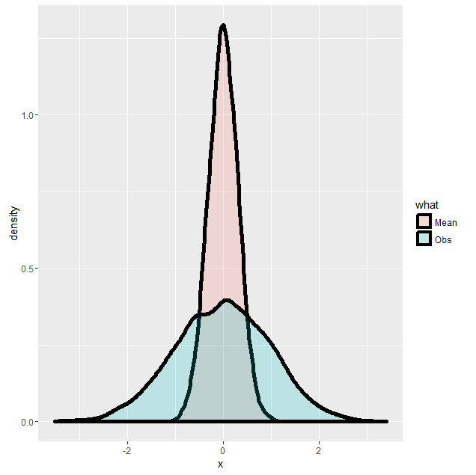

| |========================================================== | 74%

| Here's another figure from the slides. It shows how a sample mean and the mean of

| averages spike together. The two shaded distributions come from the same data. The

| blue portion represents the density function of randomly generated standard normal

| data, 100000 samples. The pink portion represents the density function of 10000

| averages, each of 10 random normals. (The original data was stored in a 10000 x 10

| array and the average of each row was taken to generate the pink data.)

... 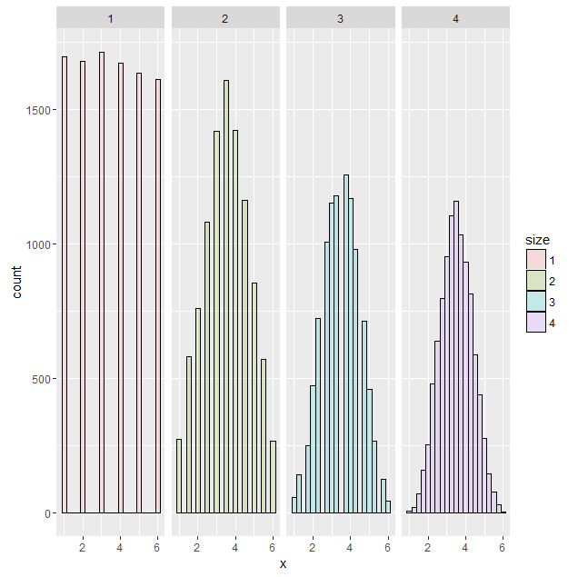

| |============================================================ | 77%

| Here's another figure from the slides. Rolling a single die 10000 times yields the

| first figure. Each of the 6 possible outcomes appears with about the same frequency.

| The second figure is the histogram of outcomes of the average of rolling two dice.

| Similarly, the third figure is the histogram of averages of rolling three dice, and

| the fourth four dice. As we showed previously, the center or mean of the original

| distribution is 3.5 and that's exactly where all the panels are centered.

...

| |============================================================== | 79%

| Let's recap. Expected values are properties of distributions. The average, or mean,

| of random variables is itself a random variable and its associated distribution

| itself has an expected value. The center of this distribution is the same as that of

| the original distribution.

...

| |=============================================================== | 81%

| Now let's review!

...

| |================================================================= | 84%

| Expected values are properties of what?

1: fulcrums

2: distributions

3: variances

4: demanding parents

Selection: 2

| Keep working like that and you'll get there!

| |=================================================================== | 86%

| A population mean is a center of mass of what?

1: a family

2: a population

3: a distribution

4: a sample

Selection: 2

| You're the best!

| |===================================================================== | 88%

| A sample mean is a center of mass of what?

1: a distribution

2: a family

3: a population

4: observed data

Selection: 4

| Great job!

| |======================================================================= | 91%

| True or False? A population mean estimates a sample mean.

1: True

2: False

Selection: 2

| Excellent work!

| |========================================================================= | 93%

| True or False? A sample mean is unbiased.

1: True

2: False

Selection: 1

| That's the answer I was looking for.

| |========================================================================== | 95%

| True or False? The more data that goes into the sample mean, the more concentrated

| its density / mass function is around the population mean.

1: True

2: False

Selection: 1

| You nailed it! Good job!

| |============================================================================ | 98%

| Congrats! You've concluded this lesson on expectations. We hope it met yours.

...

| |==============================================================================| 100%

| Would you like to receive credit for completing this course on Coursera.org?

1: Yes

2: No

Selection: 1

What is your email address? sweeyean@gmail.com

What is your assignment token? Yn5WJkhmU84qeRsk

Grade submission succeeded!

| You got it right!

| You've reached the end of this lesson! Returning to the main menu...

| Please choose a course, or type 0 to exit swirl.

1: Statistical Inference

2: Take me to the swirl course repository!

Selection: